At Last, The Secret To Coming To London Is Revealed!
Can you afford to live in a different country, like Dubai? No?
Well why not come to London?
Ever wanted to come to an area where you could put your feet up and just relax? Ever wanted to come to a place that will make you feel like you are in heaven?
There are more extravagant things to look at.
Well, London is the perfect place for you! We both know that there is a constant hustling and bustling within the city centre, but have you taken the time out to realise that there is more to London than just traffic and shops? There are many more extravagant things to look at.
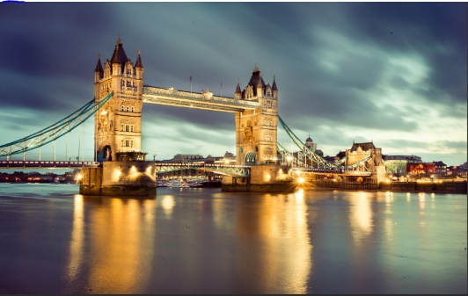
Statistics show that more than two million people live in London. It is one of the busiest cities in the U.K, and around only 20% consist of tourists shown by government data. One of the reasons why I think London is the best place for you to visit is that it provides the top cutting edge sit attractions essential for tourists. For example, the tower bridge, one of London’s oldest structures still manages to operate today.
Doesn’t the fact that it still works, (going up and down, every day) fascinate you?
Well I am 100% sure that you will find it interesting. My first visit to Tower Bridge…
It was amazing. Do not worry,, there are plenty more of attractions in London, just visit, it is as simple as that.
I am sure you will agree that there is way more to London than these attractions like Tower Bridge, London Eye and the Shard.
How does nightlife sound to you? London’s Nightlife is one of the most lively, exciting and energetic experiences that you will find, but according to scientists, it is 60% certain that the brain feels the energetic excitement at first sight of distinctive colours and patterns that have been embedded to buildings which makes London what it is today. There are a wide range of the following things: restaurant, pubs, clubs, hotels spas and other attractions to visit, whilst travelling around London.
Furthermore, independent research has shown that the human brain is only to undertake stress at a certain level. Almost 50% of the U.K’s population have suffered long term effects from stressed caused by family and also at work.
I hope you consider what is about to be said carefully.
London is the remedy to solve all stress related issues.
Yes, It is correct, although you might not believe me, but London has one of the best spa resorts and health relaxation facilities in the whole of Europe.
London’s magnificent nightlife, tourist attractions and memorable spa resorts will forever engrave a thought and feeling in both your hearth and your brain.
It will be the best experience you would have ever had.
It will make your friends jealous, it will even make you want to come back for some more excitement.
Ahh...Isn’t London just beautiful?
By Kianna Kyei-Yamoah

